Lecture 7

#### **Time Value of Money (TVM)**

* **"Time is money"**: As time passes, money loses value due to **inflation**.
  + Example: What costs **500 Rs today** won’t have the same buying power **5 years** from now.
* Formula for **Discounted Factor**:
  + **1 ÷ (1 + r)^t**, where:
    - **r = interest rate**.
    - **t = time** (usually in years).
* Example:
  + **1,000 Rs payable in 4 years**, with **8% interest**:
    - Present value = 1,000 × 0.7350 = **735 Rs** today.

#### **Cash Flow**

* **Cash Inflow**: Money entering from sales, investments, or income.
* **Cash Outflow**: Expenses, salaries, taxes, and costs of projects.
  + Example: In a **construction project**, cash inflows come from selling or leasing properties, while cash outflows are the costs of materials and labor.

#### **Discounted Cash Flow (DCF)**

Discounted Cash Flow (DCF) is a method used to estimate the value of a business or investment. It calculates how much future cash flows are worth in today’s money by applying a discount rate, which accounts for risks and time value of money.

* **Net Present Value (NPV)**: Total value of all future cash flows minus outflows
  + **NPV > 0**: The project is profitable; **invest**.
  + **NPV < 0**: The project isn’t profitable; **don’t invest**.

### 

### **Definitions:**

1. **Cash Flow**: The net amount of cash moving into and out of a business during a specific period.
2. **Inflow**: Money coming into the business, such as from sales, loans, or investments.
3. **Outflow**: Money leaving the business, including expenses, loan repayments, or investments.

### **Equation:**

**Cash-Flow=Inflow−Outflow**

This equation shows the net cash available after subtracting outflows from inflows

### **Discounted Cash Flow (DCF in Easiest Words)**

* **DCF** is a way to find out how much **future money** is worth **today**.
* Since money loses value over time (because of inflation), **DCF adjusts** future cash so we know what it’s worth **right now**.
  + Example: If you expect to get **1,000 Rs in 4 years**, DCF might say it’s only worth **735 Rs today**, because of interest rates and inflation.

### **Non-Discounted Cash Flow (Easy Explanation)**

* **Non-discounted cash flow** means looking at money coming in and going out **without considering time** or inflation.
* It simply adds up all the cash flows as they are, **not adjusting for the future**.
  + Example: If you make **500 Rs today** and **500 Rs next year**, you just count it as **1,000 Rs total**, without caring that next year’s 500 Rs will be worth less due to inflation.

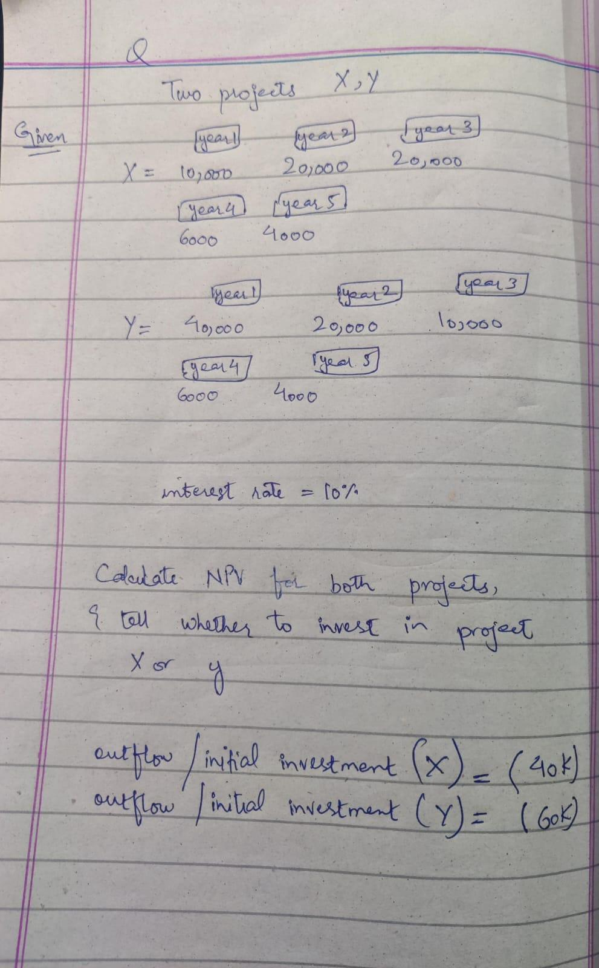

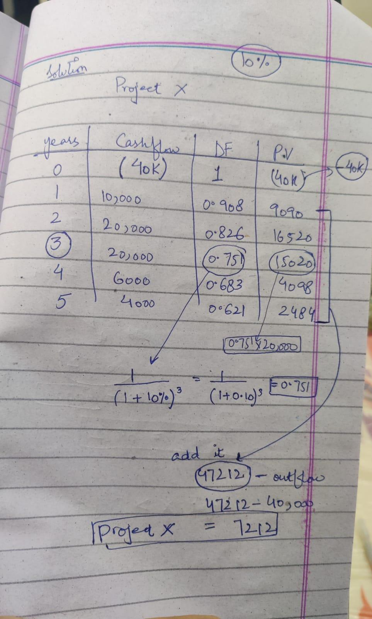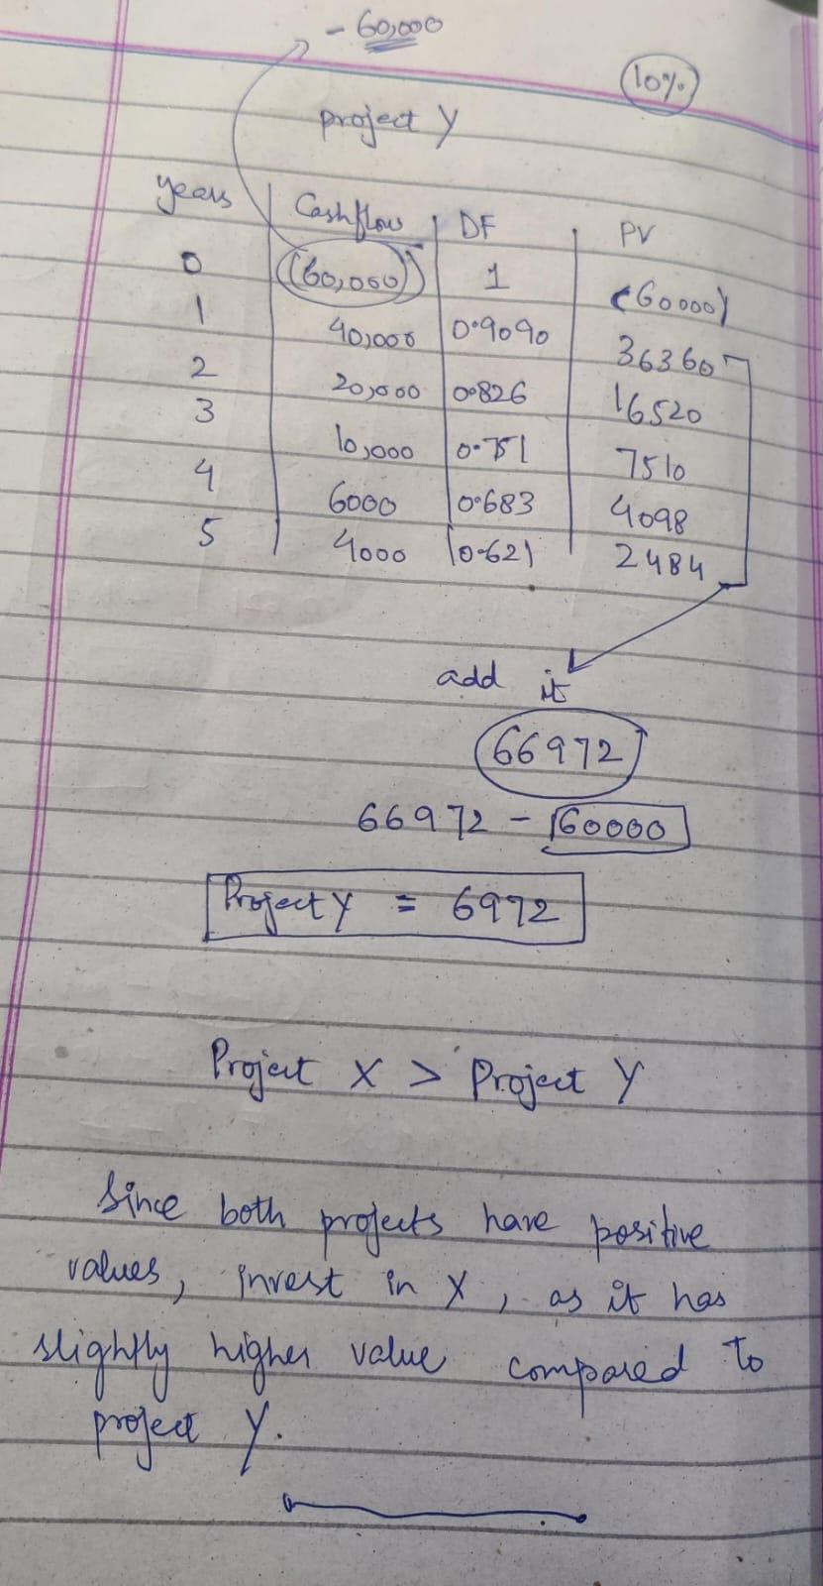

### **DCF Analysis of a Software Project**

* **Development Costs**:
  + In the first year, you hire **3 people** to develop the software. In the second year, you hire **fewer people**, reducing costs.
* **Sales**:
  + You plan to sell **100 copies** of the software for **£5,000 each** over **5 years**.
* **Marketing Costs**:
  + To promote the software, you spend more on **marketing** each year.
* **Key Metrics**:
  + **Pay-back Period**: This shows how long it takes for the money you make from sales to cover the costs you spent on development and marketing.
  + **IRR (Internal Rate of Return)**: This helps you decide if the project is profitable. If the **IRR** is **less than the cost** to fund the project (like a loan interest rate), it's not worth continuing, and you should **reject** the project.

### **Pitfalls of DCF**

* **Too dependent on assumptions**: DCF assumes that things like **sales** and **costs** will go as planned, but in real life, things might be different.
* **Uncertainty**:
  + DCF isn’t great at handling unexpected events, like a **drop in sales** or **increased costs**.
  + Example: If **software sales** drop in **year 3**, the project might not make a profit anymore.
* **Risk with long-term projects**:
  + If your project takes a long time, competitors may come up with similar products, or the market may change, making it harder to make money.

In short, DCF is helpful but **depends on predictions** about sales and costs that might not always come true.